19.46: a)
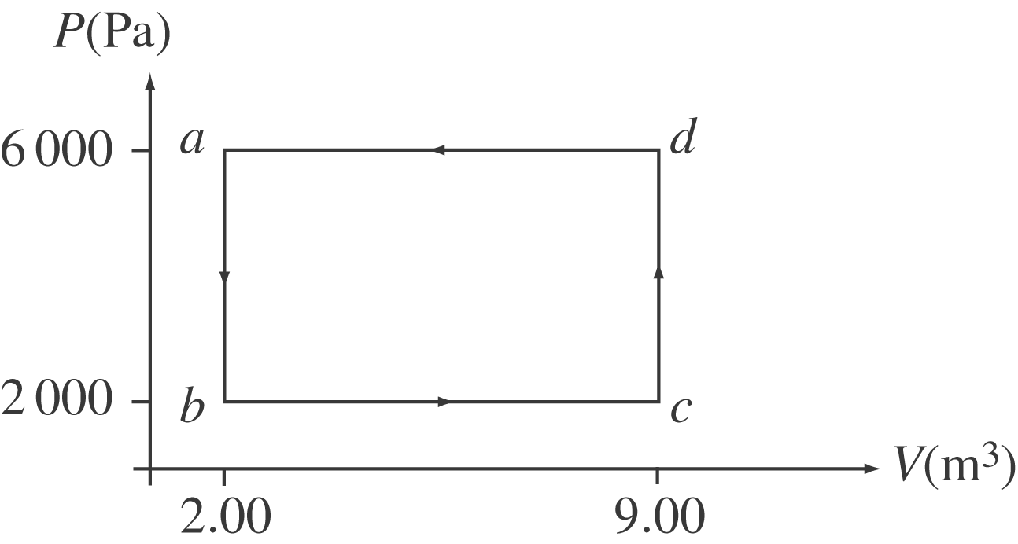

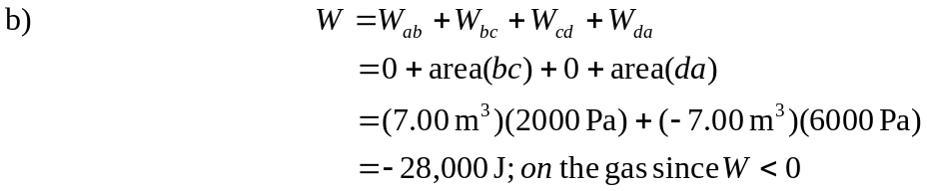

c)
Heat comes out of the gas since Q < 0.

